**How to use:**

If there is need to deploy application on different folder all that needs to be done is to

copy the files under miniurl\dist to a folder of your choice and then

to Launch the application use Miniurlservicelauncher.sh on LINUX and Miniurlservicelauncher.bat on windows.

If My SQL port is different please change the persistance.xml (located under MiniURLService.jar/META-INF) accordingly.

Once the application is launched below API/services can be used.

By default the application runs on port 4567 .

On a local machine URL will be http://localhost:4567/

/hello returns "Hello - MiniURL microServices is up!!!" is service is up

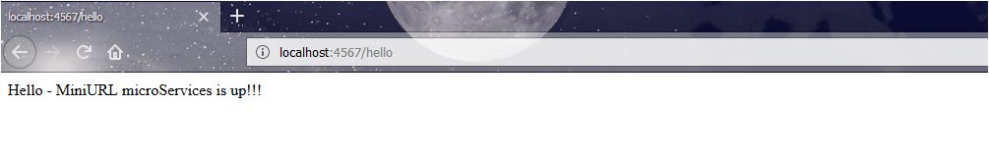

GET

/miniurl -- Returns everything

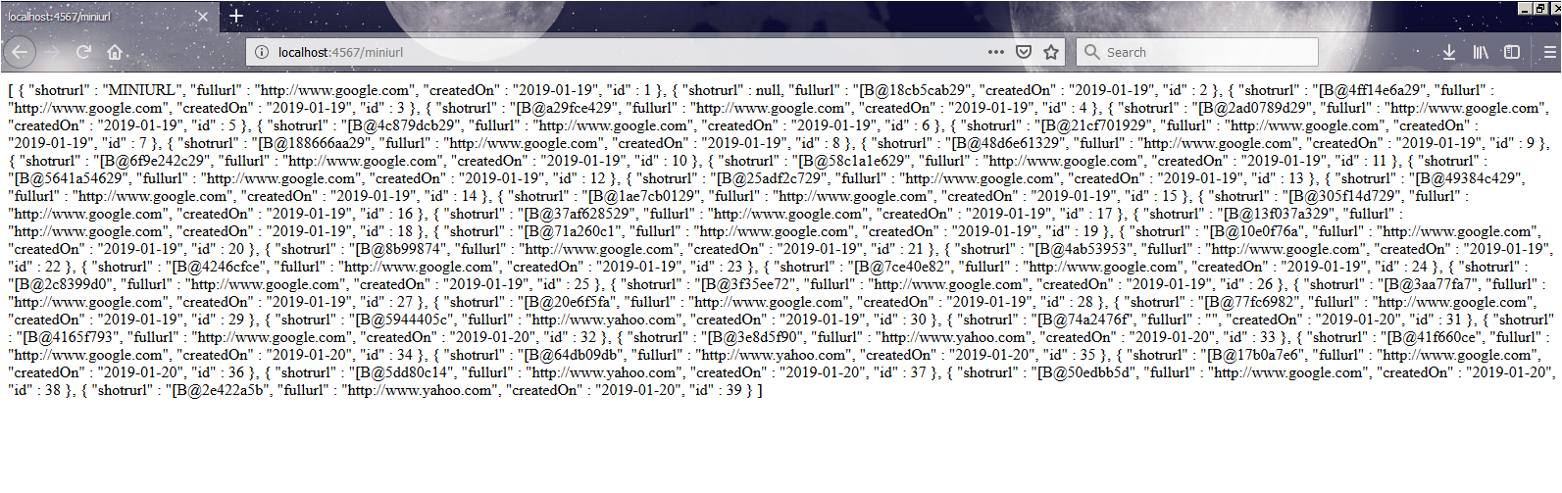

/miniurl/:id -- returns HTML with auto redirection to the full url



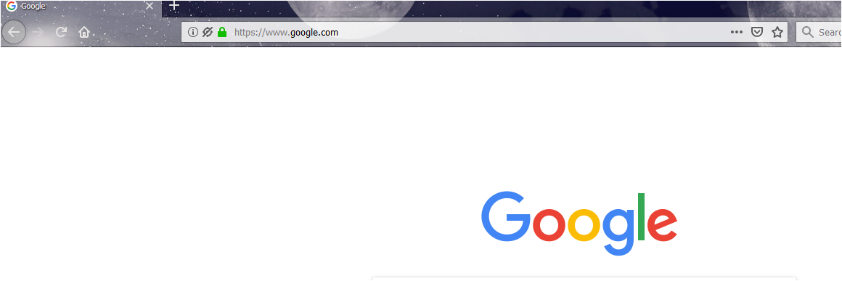

/miniurl/get/:id -- return full JSON , { "shotrurl" : "[B@2c8399d0", "fullurl" : "http://www.google.com", "createdOn" : "2019-01-19", "id" : 25 }

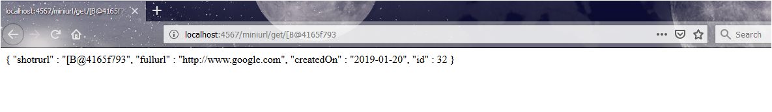

/getmini Has a HTML form to get the miniurl

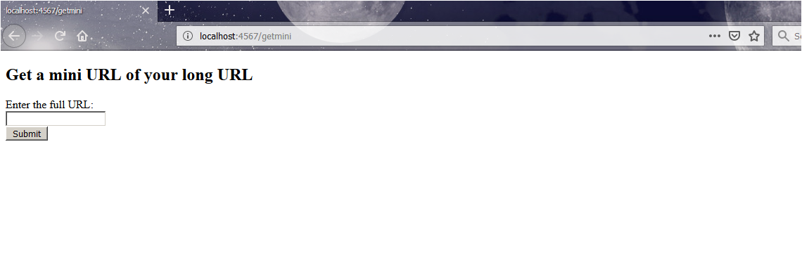

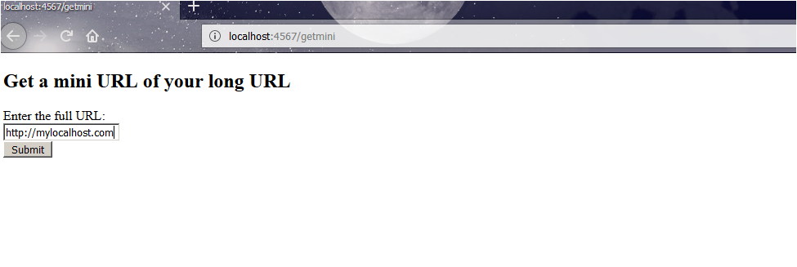

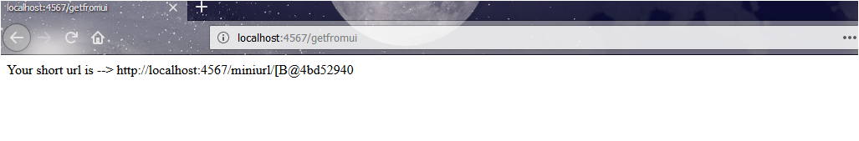

POST

/getfromui - used to get the request from UI

/miniurl --To Post a fullURL and it will return the short version retruns only the URL

REQUEST:::

[{

"fullurl" : "http://www.google.com"

},

{

"fullurl" : "http://www.yahoo.com"

}

]

Response:::

http://localhost:4567/miniurl/[B@50edbb5d

http://localhost:4567/miniurl/[B@2e422a5b

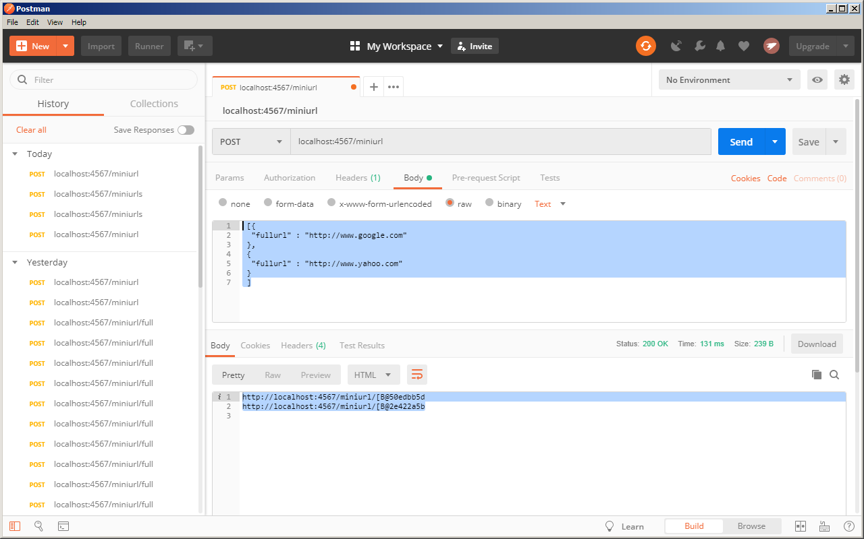

/miniurlfull --To Post a fullURL and it will return the short version retruns JSON, but shorturl will be with full context

REQUEST:::

[{

"fullurl" : "http://www.google.com"

},

{

"fullurl" : "http://www.yahoo.com"

}

]

Response:::

[ {

"shotrurl" : "http://localhost:4567/miniurl/[B@17b0a7e6",

"fullurl" : "http://www.google.com",

"createdOn" : "2019-01-20",

"id" : 36

}, {

"shotrurl" : "http://localhost:4567/miniurl/[B@5dd80c14",

"fullurl" : "http://www.yahoo.com",

"createdOn" : "2019-01-20",

"id" : 37

} ]

